LESSON 1
REAL NUMBER SYSTEM

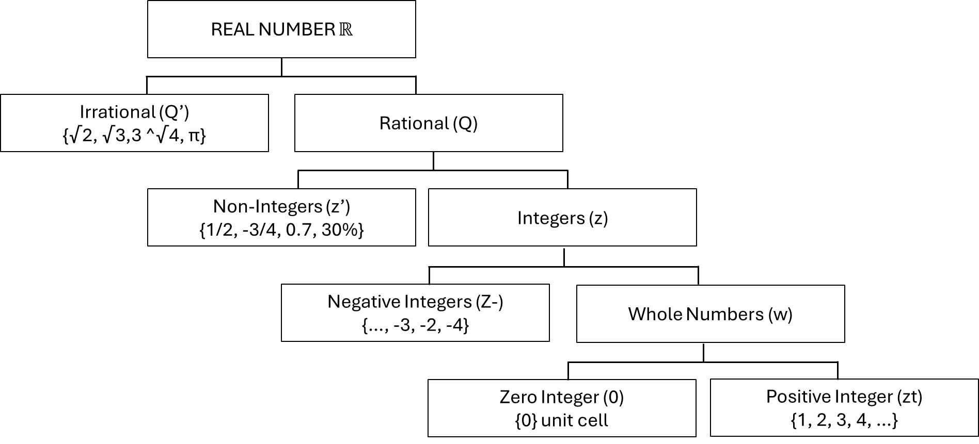

(∞) INFINITY
It is not a number, it is a symbol representing a big number.

FIELD AXIONS OF REAL NUMBER

- Axiom 1 : The closure law
for any a, b ∈ ℝ
1.1 a + b ∈ ℝ
2.2 ab ∈ ℝ

- Axiom 2 : The commutative law (for any a, b ∈ ℝ)
2.1 a + b = b + a
2.2 ab = ba

- Axiom 3 : The Association Laws
for any a, b, c ∈ ℝ
3.1 (a + b)+c = a+(b+c)
3.2 (ab)c = a(bc)
- Axiom 4 : The distribution law
for any a, b, c ∈ ℝ
4.1 a (b+c) = ab + ac CHD
4.2 (b+c) a = ba + ca RHD
- Axiom 5 : The identity law
5.1 For any 0∈ ℝ, the exist a real number called “zero” denoted by “0” sum that a+0 = a and 0+a = a.
5.2 For any a∈ ℝ, there exists a real number called “one” denoted by “1” such that a . 1 = a and 1 . a = a.

- Axiom 6 : The Inverse laws
6.1 For any a∈ℝ, there exists a real number denoted by -a, such that a + (-a) = 0 and (-a) + a = 0.
6.2 For any non-zero real number a, there exists a real number denoted by $\frac{1}{a}$, such that a ($\frac{1}{a}$) = 1 and ($\frac{1}{a}$) a = 1.

DEFINITION OF ALGEBRAIC EXPRESSION
When numbers and letters are combined by applying one or more fundamental operations of algebra, the result is called and Algebraic Expression.

POLYNOMIAL
A polynomial is an algebraic expression in which the exponent of each variable is a non-negative integer. It is written in the form…An x¹¹ + An₋₁ x⁴⁻¹ + An₂ x⁴⁻² + ….

TERMS OF POLYNOMIAL
Is a part of a polynomial separated by a plus of minus sign.
- 2x² + 2x -12
- 2x²y²z² - 3y³ (-) 2z² + w⁴

SIMILAR TERMS
A term that has the same variable raised to the same exponent.
- 2x², -4x², 7x², and $\frac{1}{2}$x²
- 3x²y³, -10x²y³, - $\frac{4}{5}$x²y³, 1.5x²y³

LESSON 2
GROUPING SYMBOLS
Grouping symbols are parenthesis ( ) , braces { } and brackets [ ].

In simplifying algebraic expressions involving grouping symbols
- remove first the inner-most grouping symbol present in the given algebraic expression.
Note: Parang sa MMW lang na groupings (unahin mong i-solve yung pinaka nasa loob)
- If a grouping symbol is preceded by a positive sign, removing it will not change the sign of all the terms inside.
- On the other hand, if a grouping symbol was preceded by a negative sign, change the sign of all the terms inside of the grouping symbol when you remove it. (Kapag may negative sign sa gilid ng isang parenthesis ibig sabihin kailangan mong palitan lahat ng sign ng nasa tabi nya na parenthesis)

ADDITION
Find the sum of the polynomials 5𝑎 − 2𝑏 + 8𝑐 , −16𝑎 + 8𝑏 + 4𝑐 𝑎𝑛𝑑 6𝑎 − 8𝑏 − 9𝑐
STEP 1 : We can write the solution as (5𝑎 − 2𝑏 + 8𝑐) + (−16𝑎 + 8𝑏 + 4𝑐) + (6𝑎 − 8𝑏 − 9𝑐)
- Para mas lalo mong magets:
Isusulat mo muna yung 2 terms
- 5𝑎 − 2𝑏 + 8𝑐 , −16𝑎 + 8𝑏 + 4𝑐
- 6𝑎 − 8𝑏 − 9𝑐

STEP 2 : Removing parenthesis will yields 5𝑎 − 2𝑏 + 8𝑐 − 16𝑎 + 8𝑏 + 4𝑐 + 6𝑎 − 8𝑏 − 9𝑐
- Pagsama-samahin mo kung alin yung magkakapareho
- 5𝑎 and − 16𝑎 and 6𝑎
- − 2𝑏 and 8𝑏 and − 8𝑏
- 8𝑐 and 4𝑐 and − 9𝑐
- Pede mo rin lagyan ng number sa baba para kung tamad kang isegregate
5𝑎 − 2𝑏 + 8𝑐 − 16𝑎 + 8𝑏 + 4𝑐 + 6𝑎 − 8𝑏 − 9𝑐
1 2 3 1 2 3 1 2

STEP 3: Combining like terms −5𝑎 − 2𝑏 + 3𝑐
- Ngayon i-solve mo na

- 5𝑎 − 16𝑎 + 6𝑎 = -5a
Solution:
5a + (-16a) = -11a → -11a + 6a = -5a
- − 2𝑏 + 8𝑏 + ( − 8𝑏) = -2b
Solution:
-2b + 8b = 6b → 6b + (-8b) = -2b
- 8𝑐 + 4𝑐 + (− 9𝑐) = 3c
Solution:
8c + 4c = 12c → 12c + (-9c) = 3c

STEP 4: Pagsamahin mo na
- 5a - 2b + 3c

SUBTRACTION
Same procedure ng addition but make sure to check kung may negative sign
Note: If a grouping symbol was preceded by a negative sign, change the sign of all the terms inside of the grouping symbol when you remove it.

STEP 1: We can write the solution as (7𝑥 2 − 2𝑥𝑦 − 14) − (3𝑥 ² + 5𝑥𝑦 − 12)
- 7𝑥² − 2𝑥𝑦 − 14
- − (3𝑥² + 5𝑥𝑦 − 12) → -3x² - 5xy + 12 (kaya naging positive yung -12 kasi negative times negative equals positive (- x - = +) pero kung negative times positive mas mabigat si negative (- x + = -)

STEP 2: Removing the grouping symbol resulting to 7𝑥² − 2𝑥𝑦 − 14 − 3𝑥² − 5𝑥𝑦 + 12
- Pagsama-samahin mo kung alin yung magkakapareho
- 7𝑥² and − 3x²
- − 2𝑥𝑦 and − 5𝑥𝑦
- − 14 and 12
Again pede ring ganto
7𝑥² − 2𝑥𝑦 − 14 − 3𝑥² − 5𝑥𝑦 + 12
1 2 3 1 2 3

STEP 3: Adding like terms will become 4𝑥² − 7𝑥𝑦 − 2

- 7𝑥² − 3x² = 4x²
- − 2𝑥𝑦 + (− 5𝑥𝑦) = -7xy
- − 14 + 12 = -2

STEP 4: Pagsamahin
4𝑥² − 7𝑥𝑦 − 2

Pedeng makahelp to:
https://www.youtube.com/watch?v=ZvL9aDGNHqA

LESSON 3
MULTIPLICATION
NOTE: The product of two polynomials is the sum of all results obtained by multiplying all the terms of one polynomial by each term of the other using the distributive law.

EXAMPLE:
Find the product of 3x²-4x and 2x²-3x-4.
Solution:
The product can be obtain by multiplying the terms of the second polynomial by 3x² and -4x and then adding the separate results.
- (3x²-4x)(2x²-3x-4)
- 3x²(2x²-3x-4) -4x(2x²-3x-4)
= 6x⁴-9x³-12x²-8x³+12x²+16x
=6x4-17x³+16x
Para mas gets mo ganto:
Yung first term which is yung 3x²-4x i-mumultiply mo sa 2x²-3x-4. Ibig sabihin ko jan yung 3x² and -4x imumultiply mo sa 2x²-3x-4.
- 3x²(2x²-3x-4)
- 3x² times 2x² = 6x⁴
- 3x² times -3x = -9x³
- 3x² times -4 = -12x²
Answer: 6x⁴-9x³-12x²
- -4x(2x²-3x-4) Same lang ang gagawin jan sa taas.
- -4x times 2x² = -8x³
- -4x times -3x = 12x² (Nagbago ang sign dahil both negative ang minultiply)
- -4x times -4 = 16x (Nagbago ang sign dahil both negative ang minultiply)
Answer: -8x³+12x² +16x
All in all: 6x⁴-9x³-12x²-8x³+12x²+16x (Pinagsama-sama ko na lahat)
- Same procedure sa addition na pagsasamahin mo na yung magkakapareho
6x⁴-9x³-12x²-8x³+12x²+16x
1 2 3 2 3 4
- 6x⁴ (nag-iisa lang naman sya na may x⁴)
- -9x³-8x³ = -17x³
- -12x²+12x² = 0
- 16x (nag-iisa lang naman sya na may x)
Final Answer: 6x4-17x³+16x
LATTICE METHOD: https://www.youtube.com/watch?v=REbWpNnBVqo

DIVISION
Divide 3x² y-6xy²+12x by 3x
Solution:
Since the divisor is monomial, we can write the solution as

(3x² y-6xy²+12x) / 3x
- (3x² y) / 3x = xy
- - (6xy²) / 3x = - 2y²
- 12x / 3x = 4
- = xy - 2y² +4

Nandito rin na yung isa pang part pano magdivide:
https://www.youtube.com/watch?v=ZvL9aDGNHqA

LESSON 4
MULTIPLICATION
NOTE: The product of two polynomials is the sum of all results obtained by multiplying all the terms of one polynomial by each term of the other using the distributive law.

